C U R R I C U L U M 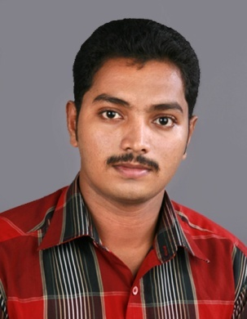

V I T A E SREEJITH P

Email: psreejithpillai@gmail.com

Mobile: +91 9947739274

Landline: 0479 2408449
C/o G Prasannan Pillai,
Kurukkathil House,
Vazhuthanam,Pallipad (P.O),
Haripad, 690512
Aleppey (Dist), Kerala

CAREER OBJECTIVE

: To Intend to work in any challenging and result oriented task with committed and dedicated people, take a career with leading corporate high-tech environment which will help me to explore myself fully and realize my potential and to attain career through progresssive training experience

FUNCTIONAL EXPERTISE

COMPUTER PACKAGES : “MS OFFICE”

SOFTWARE PACKAGES : AUTO CAD , PRO/E

SOFT SKILLS

- Presentation and public speaking

- Training and facilitation

- Documentation

- Event planning and coordination

EDUCATION

MASTER OF BUSINESS ADMINISTRATION from AMITY GLOBAL BUSINESS SCHOOL,KOCHI
Persuing third semester.(operations and marketing)

B.E MECHANICAL ENGINEERING from ANNAI MATHAMMAL SHEELA ENG: COLLEGE, Anna University. CHENNAI

Percentage: 69%

Year: 2010

HIGHER SECONDARY EDUCATION from Board of Higher Secondary.Education, kerala

Percentage: 63.8%

Year: 2005

SSLC from NADUVATTOM V H S S, Naduvattom p.o, Kerala,

Board of Public Exams,kerala

Percentage: 73.3%

Year: 2003

COMPLETED PROJECT

“CUSTOMER PERCEPTION , AWARENESS AND ACCEPTANCE LEVEL OF ACUVUE” FOR JOHNSON AND JOHNSON LTD

This project aims to find out customer perception and acceptance level of Acuvue contact lenses within the market regions . It was undertaken to analyse the awareness level , customer perception and acceptance level of Acuvue lenses for enhancing the business of the company by providing the company with the vital statistics and information collected from the market so that it helps the product to gain confidence among the customers

“FABRICATION OF HOVER CRAFT MODEL”

ABSTRACT
A hover craft (air-cushion vehicle,ACV) is a craft capable of traveling over relatively
Smooth surfaces supported by a cushion of slow moving,high –pressure air,ejected
against the surface below ,and contained within a “skirt” .Hovercrafts are used
throughout the world because of their ability to travel equally well over land,ice and
water.

“AUTOMATIC WIPER CONTROLLER”

ABSTRACT
A windscreen wiper is a device used to wipe rain and dirt from windscreen.Almost all
motor vehicles ,including trains ,aircraft and watercraft, are equipped with
windscreen wipers.This project deals with automatic rain operated wiper.

PERSONAL QUALITIES

: Excellent communication skills, leadership
quality, ambitious, energetic, optimistic,
hard worker.

PERSONAL INFORMATION

Father’s Name : G PRASANNAN PILLAI

Date of birth : 22/11/1987

Marital status : SINGLE

Languages know : HINDI ,ENGLISH ,MALAYALAM ,TAMIL.

Nationality : INDIAN

Permanent Address : SREEJITH P
KURUKKATHIL HOUSE
VAZHUTHANAM ,PALLIPAD P.O.
HARIPAD, ALEPPEY(DIST)
Kerala, pin:690512

Reference

- Ready to submit as on demand.

Declaration

I hereby declare that the above written particulars are true to the best of my knowledge and belief.

Place: Sreejith p

